Working With Dataset

# BP Variation With Respect To Age

|  |  |
| --- | --- |
| Team ID | PNT2022TMID04459 |
| Project Name | Visualizing and Predicting Heart Diseases with an Interactive Dashboard |

## Visualization:

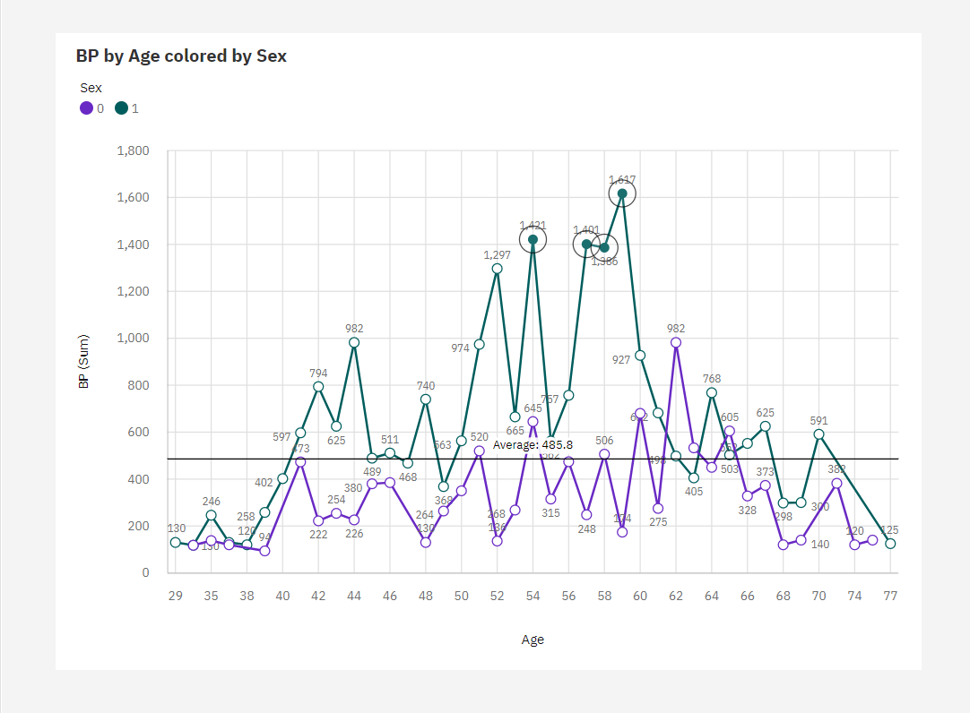

1. For **BP**, the most significant value of **Age** is 54, whose respective **BP** values add up to over two thousand, or 5.8 % of the total.
2. **BP** is unusually high when **Age** is 54.
3. For **BP**, the most significant value of **Sex** is 1, whose respective **BP** values add up to almost 24 thousand, or 67.4 % of the total.
4. BP is unusually high when the combinations of Age and Sex are 59 and 1, 54 and 1, 57 and 1 and 58 and 1.